**SUHasHeart**



Client: Trina Tardone

Organization: American Heart Association

William Chen, Marisa Fischetti, Taylor Rashti, Benjamin Wichman

Table of Contents

SUHasHeart Fundraising Page………………………………………… 3

Instagram Overview…………………………………………………… 5

Instagram posts………………………………………………………… 6

**SUHasHeart Fundraising Page**

<https://ahasyracuse.ejoinme.org/MyEvents/20202021SyracuseGoRedForWomen/Fundraising/tabid/1112565/Default.aspx?joinme=447322>

SUHasHeart created a fundraising page for anyone who wants to donate to the American Heart Association to show their support for heart health during the pandemic.

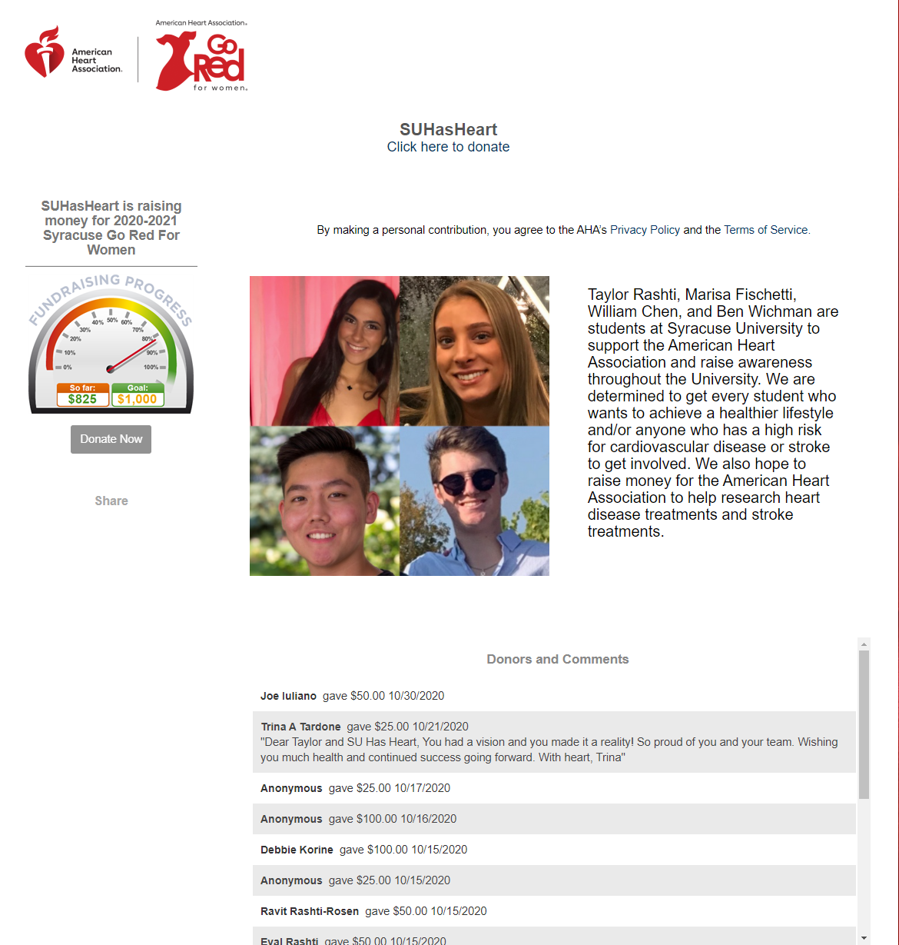

**Text:** Taylor Rashti, Marisa Fischetti, William Chen, and Ben Wichman are students at Syracuse University to support the American Heart Association and raise awareness throughout the University. We are determined to get every student who wants to achieve a healthier lifestyle and/or anyone who has a high risk for cardiovascular disease or stroke to get involved. We also hope to raise money for the American Heart Association to help research heart disease treatments and stroke treatments.

**SUHasHeart Instagram Overview**

<https://www.instagram.com/suhasheart/>

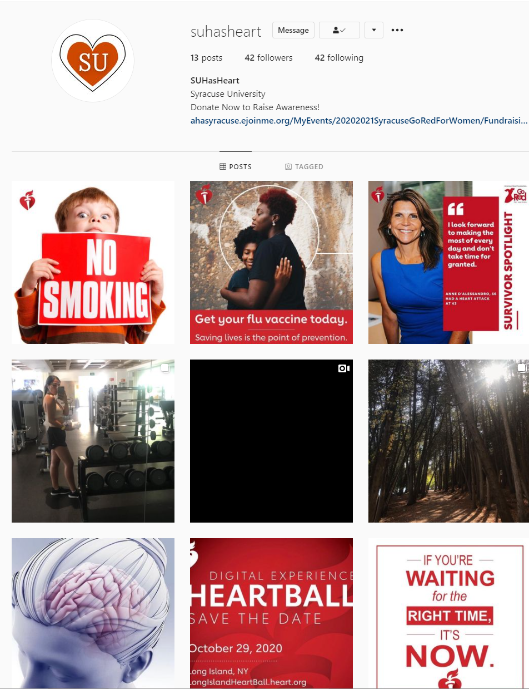

**SUHasHeart Instagram Posts**

